USEFUL APPS TO PRATICE LISTENING

Try out all of them!

 | - BBC: 6 Minute English https://www.bbc.co.uk/learningenglish/english/features/6-minute-english
 | - TedTalk https://www.ted.com/
 | - LearnEnglish Podcasts (App for IOS and Android)
 | - Duolingo (App for IOS and Android)
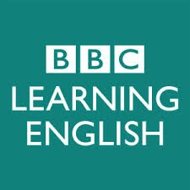 | - BBC: Learning English Podcast https://open.spotify.com/playlist/1KcHsZpV8IHpDalpRyiFYi?si=hKl1zBdCSHasFzT_p3joHA

