Most common words in English language

The word | Synonym /  Phrasal verbs | Antonym /  The opposite
Great (adjective) | Marvelous | Poor
New (adjective) | Recent | Outdated
Bad (adjective) | Awful | Pleasant
Thing (noun) | Case | Whole
Problem (noun) | Issue | Advantage
Way (noun) | Approch | Ignorance
Have (verb) | Own / Get hold of | Lack
Do (verb) | Accomplish / Carry out | Hesitate
Use (verb) | Employ/ Bring to bear | Let go

The strategy
- Check your text for words that repeat (circle them).
- See if your text has any of “most common words in English language” (circle them).
- Replace the circled words for synonyms, phrasal verbs and negative antonyms with the help of synonym dictionaries.

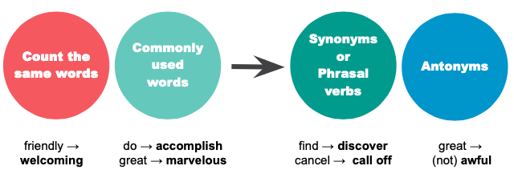

1 Detect commonly used words and words that repeat, change them using “the strategy” to transform the text.

Ancient Egypt
The ancient Egyptians created many impressive structures. What is most impressive is that they built these buildings without the help of the machines we have today. Some of the most famous buildings the ancient Egyptians built were the pyramids. The whole process was done miraculously.
2 Paraphrase the text by replacing the underlined words and phrases with synonyms. Some sentences might need to be changed.
- All of the people in class studied hard. As a result there was a big rise in test scores.
____________________________________________________
____________________________________________________
- The weather forecast says it will be mostly windy and rainy over the next few days. In addition, a strong typhoon will hit the coast next Wednesday.
____________________________________________________
____________________________________________________

- A science teacher caught two high school students smoking outside the school cafeteria. This action made the principle to kick them them out for breaking the school’s no smoking rule.
____________________________________________________
____________________________________________________

