There are five different text structures: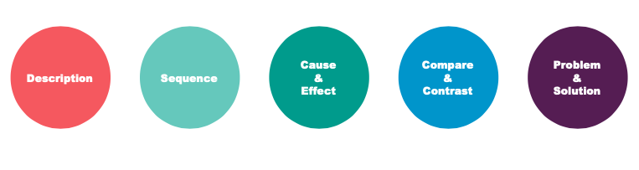
1 Detect the structure of the given text and circle the words that signal the particular structure.

1 ____________________________________
Many students in the US schools face the problem of bullying. Natalie Hampton is a high school student who was bullied a lot in middle school. She often had no one to sit with at lunch. So she created a phone app called "Sit With Us." This app lets students sign up and post when there are free seats at their lunch tables. These students have promised to be kind to those who come sit with them.

2 ____________________________________
A river is a large natural stream of flowing water. The source of a river is the place where the river starts. This is usually the highest point in the river. Many rivers begin in springs, places where underground water flows to the Earth’s surface.

3 ____________________________________
Robots that look like humans are called androids. But not all robots are androids. The industrial robots used in manufacturing and production look like machines and not at all like human beings. So what does an android have in common with an industrial robot? They both have computers. And they both have sensors to gather information and ways to interact with their environments, too.

4 ____________________________________
A current is a steady flow of water in the ocean. In the Pacific Ocean, garbage from the shore and ships gets trapped by ocean currents. Therefore, currents move the trash into a large area in the middle of the ocean. This has created a swirling mass of plastics and seawater called the Great Pacific Garbage Patch.

5 ____________________________________
Firsty, to begin a productive day, when waking up, you shouldn't push the snooze button. Secondly, you should begin the day with a morning stretch or a run. And lastly, think of the food that you consume, because the saying goes “You are what you eat”.

2 Make a diagram about living in Urban and Rural areas.Then write a text using one of the text structures about the information that you included in the diagram.

Urban In common Rural

