The Handout ‘Speaking: The Monologue’

User Guide
(a) in the handout you may use both theoretical information (📊description and definition of bars/charts, and 📝useful vocabulary), and 🗣 practical tasks (speaking papers);
(b) the speaking papers may be printed out and used for the exam preparation;
(c) the feedback on improving the handout is welcomed.

📊 Types of Charts and Graphs
Explore one of the main characteristics of a chart and a graph (see Table 1) to get a clear notion how you may both deal with them during your speaking part, moreover, how to use them in future. It is advisable that you try to analyse it together with a classmate, a friend, a parent or a teacher. Afterwards, you will be more successful in describing charts and graphs, what is more important - understanding them (Macmillan Dictionary, n.d.; Microsoft: Educator Center, n.d.; Valcheva, n.d.).

Table 1. The Definitions of the Charts and Graphs
The Type of a Chart or a Graph | The Definition and Vocabulary
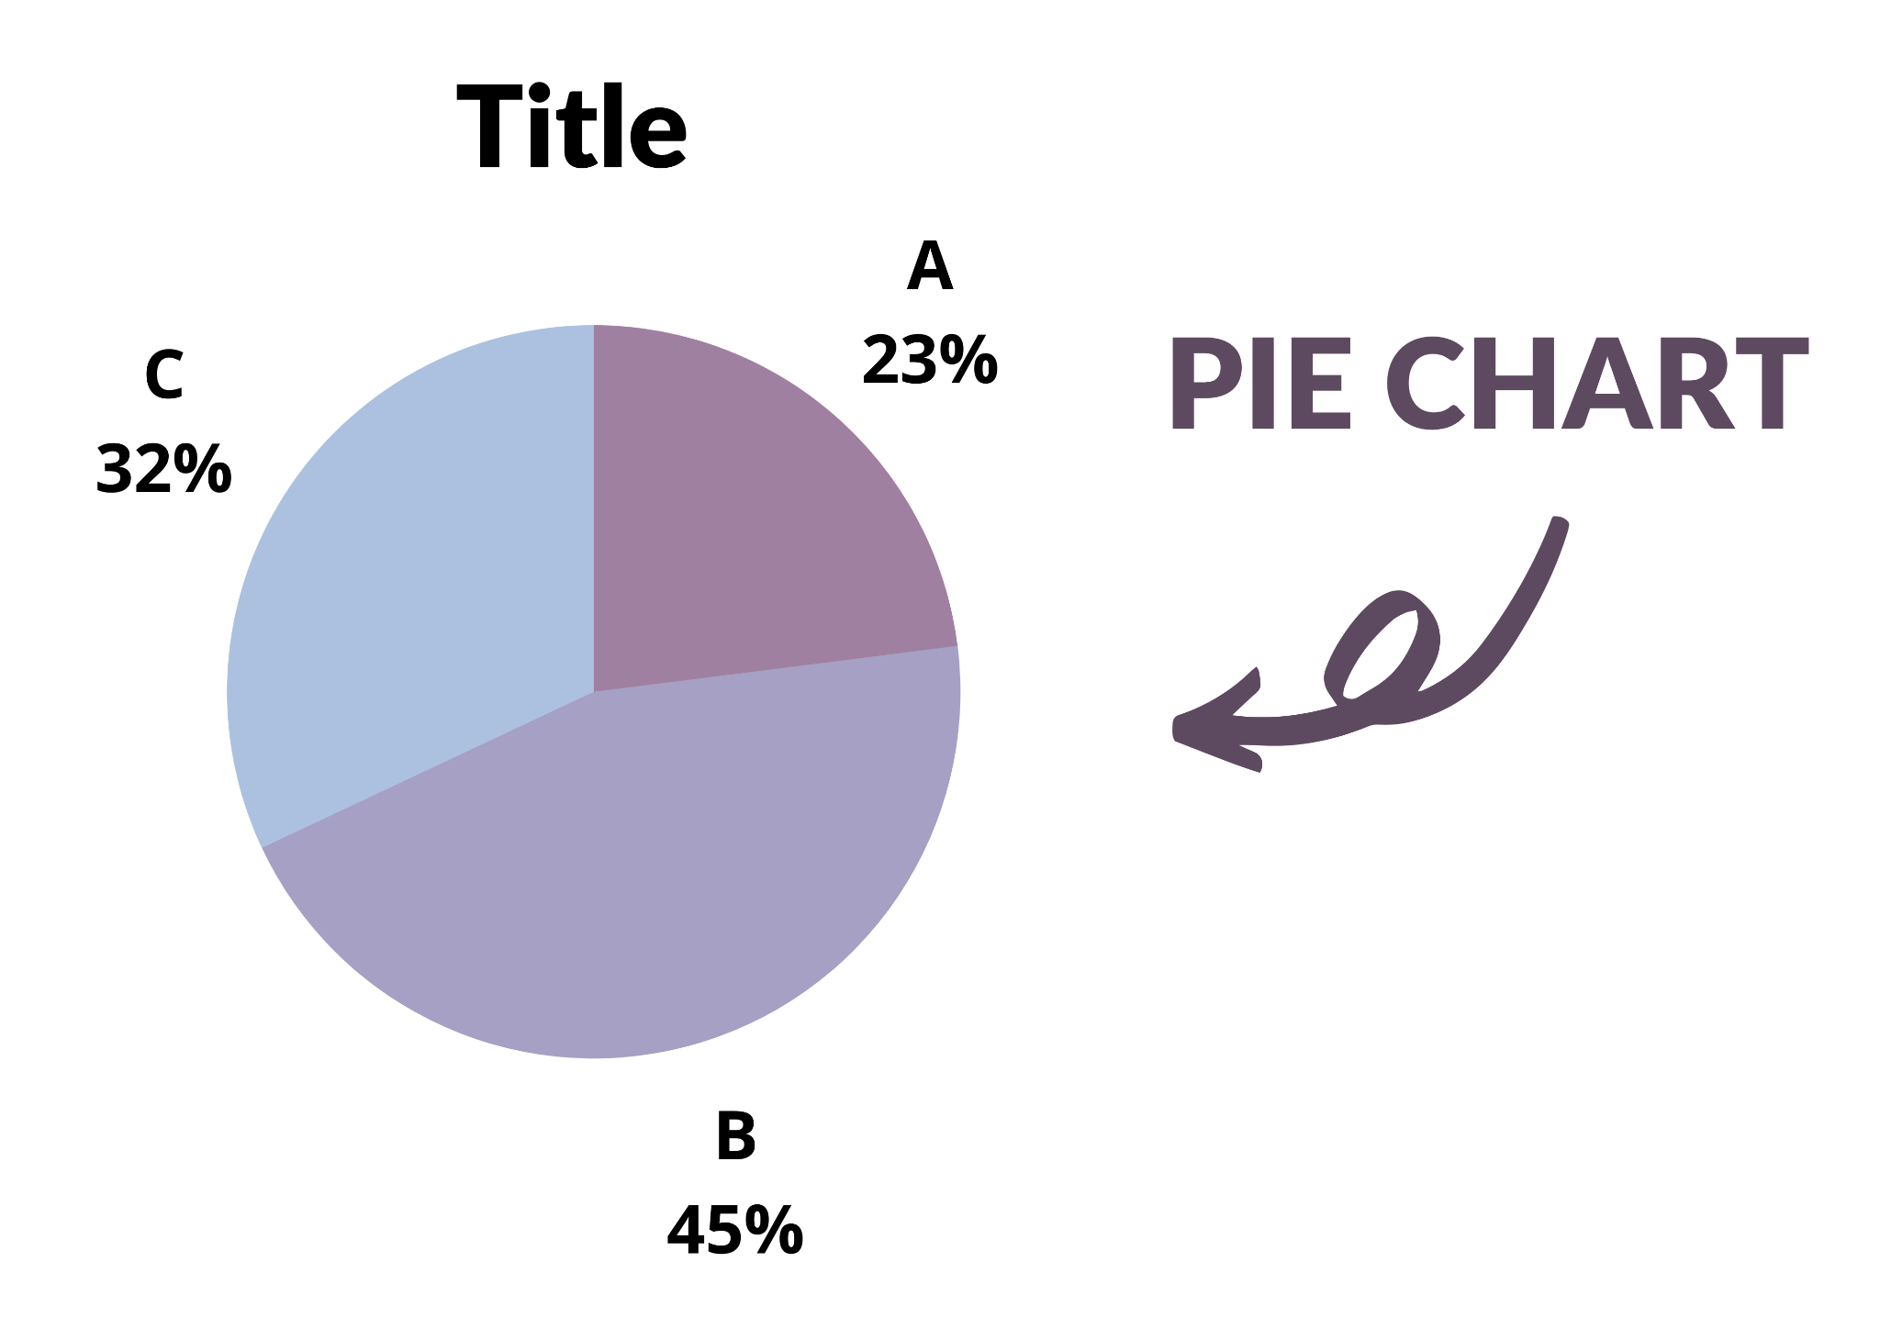 | Pie Chart - a circle divided into sections in order to show how something is divided into different amounts.  Each pie is split into slices with each slice representing one particular group of data. The size of the slice shows you how much of that group of data you have.  Picture: canva.com
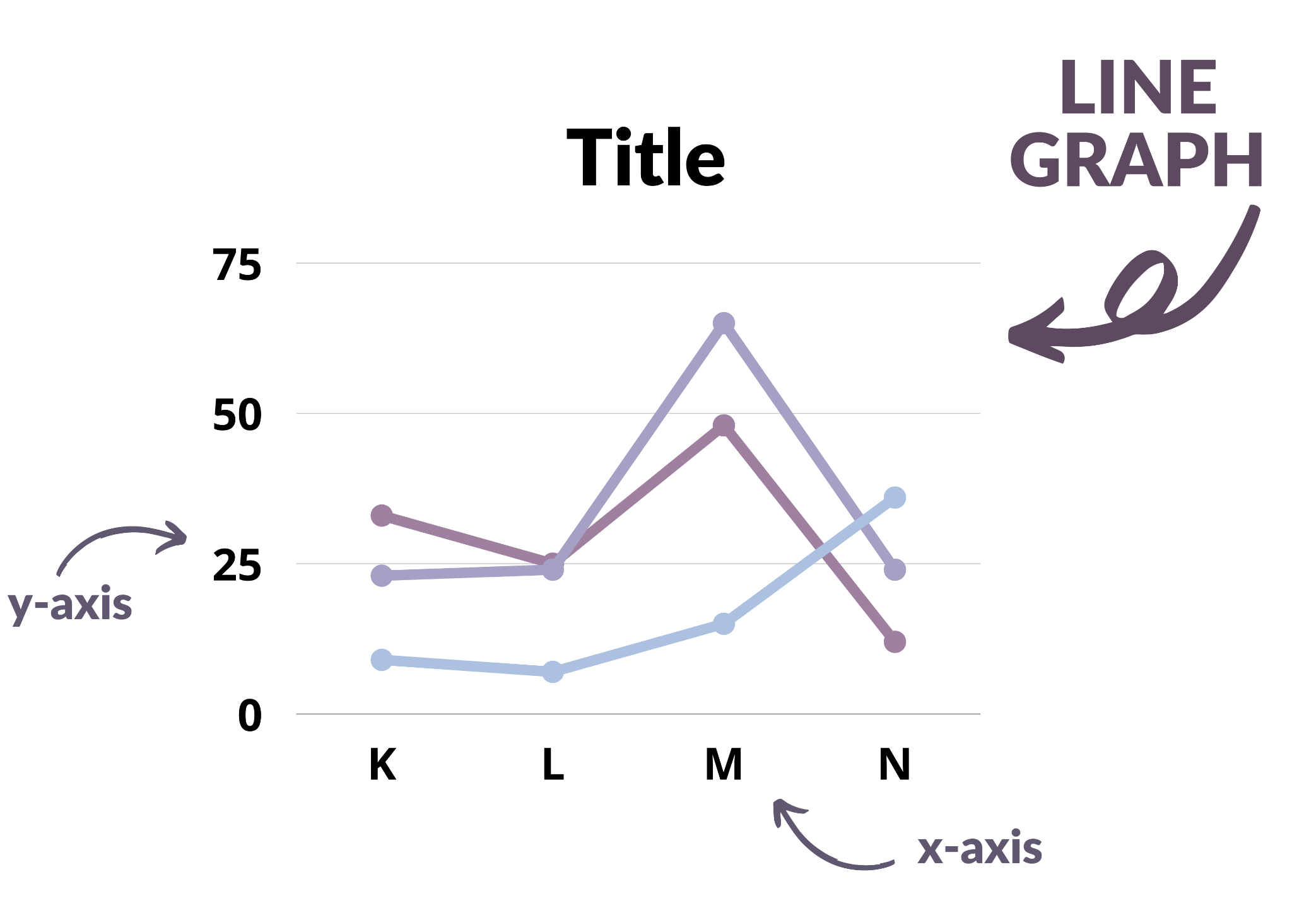 | Line Graph - a graph that uses lines to show the relationship between numbers or measurements that change.  X-axis - a fixed line that goes from left to right and is used for showing measurements or for finding the position of points on a graph.  Y-axis - a fixed line that goes from top to bottom and is used for showing measurements or for finding the position of points on a graph.  Picture: canva.com
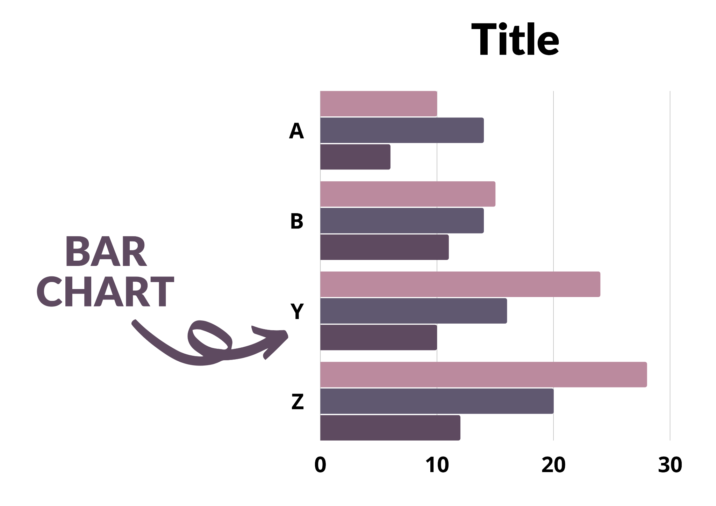 | Bar Chart - a graph that represents different amounts or values as thick lines of different lengths.  Each rectangular bar has length and height proportional to the values that they represent.  One axis of the bar chart presents the categories being compared. The other axis shows a measured value.  Picture: canva.com
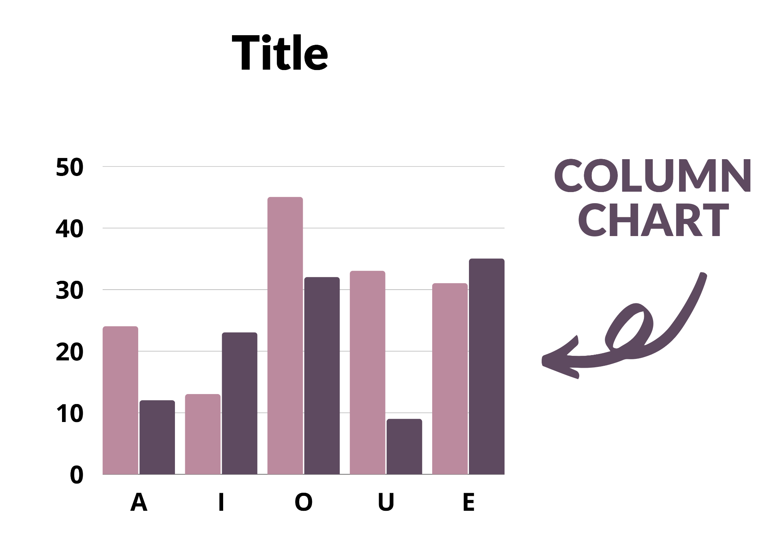 | Column Chart - a good way to show change over time because it's easy to compare column lengths.  Like bar charts, column charts can be used to plot both nominal data and ordinal data, and they can be used instead of a pie chart to plot data with a part-to-whole relationship.  Picture: canva.com
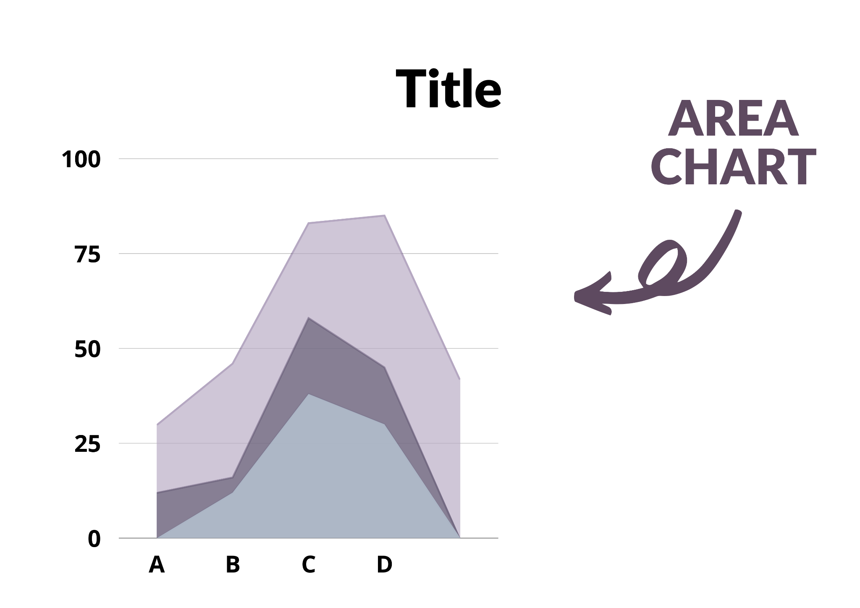 | Area Chart - shows the change in one or several quantities over time. They are very similar to the line chart. However, the area between the axis and line is usually filled with colours.  They are helpful for us to understand various statistical measures and trends like part-to-whole comparison, trend comparison for more than one portion, a measure of change  Picture: canva.com

Find out more: Microsoft: Educator Center. (n.d.). How to create effective charts and diagrams. https://education.microsoft.com/en-us/course/0a60eeb6/7
📝Linking Devices and Useful Vocabulary
Use the provided materials to improve and boost the vocabulary in your monologue and speaking in general. You may find some new words according to their part of the speech (see Table 2). It is highly recommended to use some of the new phrases from the linking devices, do not memorise everything - it is better to choose several linkers that you like the most. Practise using them with your classmates, peers or a teacher (IELTS Academy, n.d.). You may also do it on your own in front of the mirror, because - why not? 😊

Table 2. Expressing the Increase or Decrease
Verbs | Nouns |  | Adjectives | Adverbs
rise (to) | a rise |  | dramatic | dramatically
increase (to) | an increase |  | sharp | sharply
grow (to) | growth |  | enormous | enormously
climb (to) | a climb |  | considerable | considerably
peak (at) | (reach) a peak (at) |  | significant | significantly
fall (to) | a fall (of) |  | slight | slightly
decline (to) | a decline (of) |  | sharp | sharply
decrease (to) | a decrease (of) |  | huge | hugely
reduce (to) | a reduction (of) |  | rapid | rapidly
drop (to) | a drop (of) |  | gradual | gradually

There are several aspects you should remember about explaining the data according to the charts/graphs/diagrams. For instance, the correct use of tenses when describing a chart. If the chart deals with facts in the present, use the Simple Present, if the facts are the past, then use the Simple Past. If there is a connection between the past and the present, use the Present Perfect. It is important that you introduce the visual data by using one of the following phrases or collocations (Castro, 2021):

Introducing visuals

- According to the table/ graph/chart…
- The table/graph/chart shows…
- The table/graph/chart illustrates…
- Looking at the table/chart/graph, it can be seen that…
- The table/graph/chart provides information about…
- Let's have a look at this model/graph/chart...
- To illustrate my point let’s look at some diagrams...
- As you can see from these figures...
- If you look at this bar chart you'll notice...

After introducing the visual data, you will be expected to describe the main trends presented in the table, graph and/or chart. Below (see Table 3) are different phrases and collocations that you can use to describe a variety of trends:

Table 3. The Phrases to Describe the Charts and Graphs
↗ | ↘ | ↗ ↘
- a significant increase  - a considerable growth  - to increase dramatically  - to rise sharply  - to show an upward trend | - a sharp fall  - a significant drop  - to decline sharply  - to show a downward trend  - to hit the lowest point | - to reach a peak/high  - at its peak  - all-time peak  - to rise towards its peak  - past its peak
↗ ↘ ↗ | → | ⎇
- a considerable variation  - a slight fluctuation  - to vary considerably  - to show some fluctuation | - a period of stability  - to remain stable  - to remain constant | - to level off  - to flatten out  - to reach a plateau

Here you may find some other useful expressions to analyse successfully the chart, graphs, and diagrams (Business English, 2008):

Naming the parts of diagrams
- The vertical axis (y axis) represents total annual sales.
- The horizontal axis (x axis) shows our market share.
- The curve,
- The solid line,
- The dotted line,
- The broken line,
- The shaded area,
- The unshaded section,
- The dotted column,
- The coloured segment,
- The red bar…

It is crucial to understand the data (see Table 4), thus you should be sure about naming the provided numbers correctly (Grussendorf, 2007):

Table 4. Naming the Numbers from Charts and Graphs
The Number | The Phrase
500 | five hundred
1,500 | one thousand five hundred
350,421 | three hundred and fifty thousand, four hundred and twenty-one
211,050,780 | two hundred and eleven million, fifty thousand, seven hundred and eighty
10.6 | ten point six
8.735 | eight point seven three five
0.009 | zero point oh oh nine
-5ºC | five degrees below zero Celsius
½ | one-half; a half
2/3 | two-thirds
7/8 | seven-eighths
km/h | kilometres per hour

The last section of the provided vocabulary, is devoted to the phrases and linking devices you may use in any monologue in general (Grussendorf, 2007):

The objective of your presentation:
- My objective this morning/afternoon is to inform you...
- I'm here today to give you...
- In this talk, I/we would like to concentrate on…
- My purpose today is to introduce you to...
- My aim this morning is to...

Structuring and sequencing:
- My presentation is split into three key areas.
- Firstly ... Secondly ... Thirdly ...
- To begin with ... After this ... Finally ...
- I’ll begin/start off by... Then I’ll move on to... Then/Next/After that, I’ll be looking at...

Introducing topics:
- In this part of my monologue/presentation, I’d like to talk about…
- I want to look at ...
- I'd like to review ...
- I want to discuss ...
- I'm going to analyse ...
- I want to cover ...
- I'd like to talk about ...

Moving on:
- Let's now move on to ...
- I'd like to go on to ...
- This brings me to ...
- I now want to ...

Looking back:
- Let's look back for a moment ...
- As I pointed out…
- To go back to ...
- Referring to…
Adding:
- In addition ...
- I might add that …
- Furthermore ...
- Moreover ...

Summarising and concluding:
- Let me briefly summarise the main issues…
- To sum up then, ...
- To summarise my main points ...
- I'd like to conclude by reminding you that ...
- Let me end by ...
- I'd like to finish ...
- In conclusion, may I remind you ...
- Finally, ...

🗣 Speaking Part (Monologue: B2 Level)
When the main characteristics of a chart and a graph were explored, as well as the most necessary vocabulary was studied, it is the best time to go one to the main activity of the speaking part - the monologue! According to the programme of the exam in English in form 11 (Skola2030,2021), there are the following rules about the monologue:

- The speaking part consists of the three parts:
  - Part 1: examine the texts and/or graphs characterising some specific issue you chose from the papers offered. You will be given 5 minutes to develop a plan for your own presentation;
  - Part 2: present your opinion on the issue (up to 5 minutes);
  - Part 3: answer a few examiner’s questions probing some particular nuances of your presentation as well as other aspects not covered in your presentation.

Whether it is a paper with two texts, or it is a paper with a chart/graph/diagram and a text, you will have this plan of your monologue:

Deliver the talk in which you:
- formulate the issue raised in the materials;
- compare the information provided in the materials;
- state your opinion on the issue;
- support your opinion by at least two arguments giving reasons and examples;
- come to a conclusion.

You may found the following topics of a monologue with a text and a chart/graph/diagram for you speaking part practice, where the texts have been taken from the previous exams dedicated to Form 12:

- Paper 1: money management;
- Paper 2: perfectionism;
- Paper 3: procrastination;
- Paper 4: sleep;
- Paper 5: consumerism;
- Paper 6: laziness.
Paper 1

You are taking part in an English debate club discussion on money management. You should give a talk in which you present your opinion on the issue. Study the provided materials (their format, content, arguments) in order to plan your talk.

1) Deliver the talk in which you:
- formulate the issue raised in the materials;
- compare the information provided in the materials;
- state your opinion on the issue;
- support your opinion by at least two arguments giving reasons and examples;
- come to a conclusion.
2) Answer the teacher’s (opponent’s) questions and justify your answer.

You have up to 5 minutes to plan your talk. Speaking time: 3–5 minutes

At high school, every teenager can have a part time job, earn their own money, and open a bank account. It is interesting how teens’ spending habits change when it is their own, rather than their parents’ money. They also take better care of clothes and other items that they buy on their own. Having a good part time job is also good for learning time management skills, developing confidence, learning about the world of work, and building a resume. | 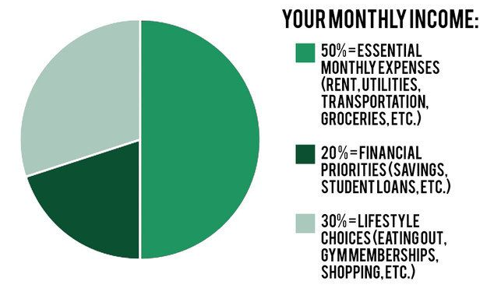  Figure 1: The Rule of Budgeting 50/20/30
(Based on: How to Manage Your Budget [online]. 2020, May 15.
Available: https://www.psychologytoday.com/intl)

Questions:
- How will your financial priorities change in 5 years?
- How did you spend your money in childhood?
- What would you do if you got three thousand euros?

Paper 2

You are taking part in an English debate club discussion on perfectionism. You should give a talk in which you present your opinion on the issue. Study the provided materials (their format, content, arguments) in order to plan your talk.

1) Deliver the talk in which you:
- formulate the issue raised in the materials;
- compare the information provided in the materials;
- state your opinion on the issue;
- support your opinion by at least two arguments giving reasons and examples;
- come to a conclusion.
2) Answer the teacher’s (opponent’s) questions and justify your answer.

You have up to 5 minutes to plan your talk. Speaking time: 3–5 minutes

Many of us believe perfectionism is a positive quality. Thomas Curran, PhD and Andrew Hill, PhD define perfectionism as “an irrational desire for achievement along with being overly critical of oneself and others.”  They explain that today’s generation has “the strong need” to achieve “increasingly unrealistic educational  and professional expectations”. Resisting perfectionism does not mean giving up your quest to do well, or that you have to give up ambition, but overdoing it can have negative consequences. | 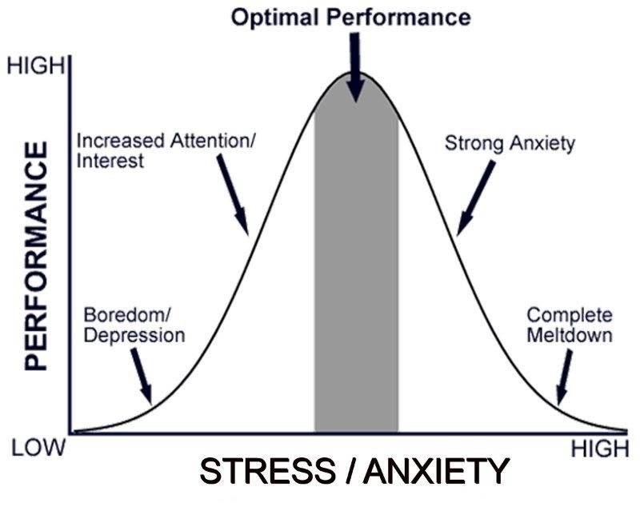
(Based on: How Stress Influences Anxiety [online]. 2021, June 9.
Available: https://www.psychologytoday.com/intl)

Questions:
- Is stress linked to anxiety and panic attacks?
- How can you help people who are perfectionists?
- What are the risk factors/triggers for anxiety disorders?

Paper 3

You are taking part in an English debate club discussion on procrastination. You should give a talk in which you present your opinion on the issue. Study the provided materials (their format, content, arguments) in order to plan your talk.

1) Deliver the talk in which you:
- formulate the issue raised in the materials;
- compare the information provided in the materials;
- state your opinion on the issue;
- support your opinion by at least two arguments giving reasons and examples;
- come to a conclusion.
2) Answer the teacher’s (opponent’s) questions and justify your answer.

You have up to 5 minutes to plan your talk. Speaking time: 3–5 minutes

According to traditional thinking, procrastinators (people who delay or put things off) have a time management problem. Increasingly, however, psychologists are realising this is wrong. Experts at Carleton University have proposed that procrastination is an issue with managing our emotions, not our time. The task we are putting off is making us feel bad – perhaps it is boring, too difficult or we are worried about failing – and to make ourselves feel better in the moment, we start doing something else, like watching videos.

(Based on: Ways of Procrastination [online]. 2021, March 21.
Available: https://www.bbc.com/)

Questions:
- How do you feel when other people put off something you want done soon?
- Does your need for completing things right interfere with your relationships?
- What is the cause of being lazy in education?
Paper 4

You are taking part in an English debate club discussion on sleep. You should give a talk in which you present your opinion on the issue. Study the provided materials (their format, content, arguments) in order to plan your talk.

1) Deliver the talk in which you:
- formulate the issue raised in the materials;
- compare the information provided in the materials;
- state your opinion on the issue;
- support your opinion by at least two arguments giving reasons and examples;
- come to a conclusion.
2) Answer the teacher’s (opponent’s) questions and justify your answer.
You have up to 5 minutes to plan your talk. Speaking time: 3–5 minutes

Adolescents need about 9 hours of sleep a night to function optimally – to be physically, mentally and cognitively healthy. Tell this to nine out of ten teenagers and they will laugh. In fact, only about 8 percent of American teenagers get the sleep they need, according to a recent study in the Journal of Adolescent Health. The rest live with chronic sleep deprivation – some mild to moderate, but more than half (59%) with severe sleep deprivation, meaning they sleep on average six hours or less most school nights. | 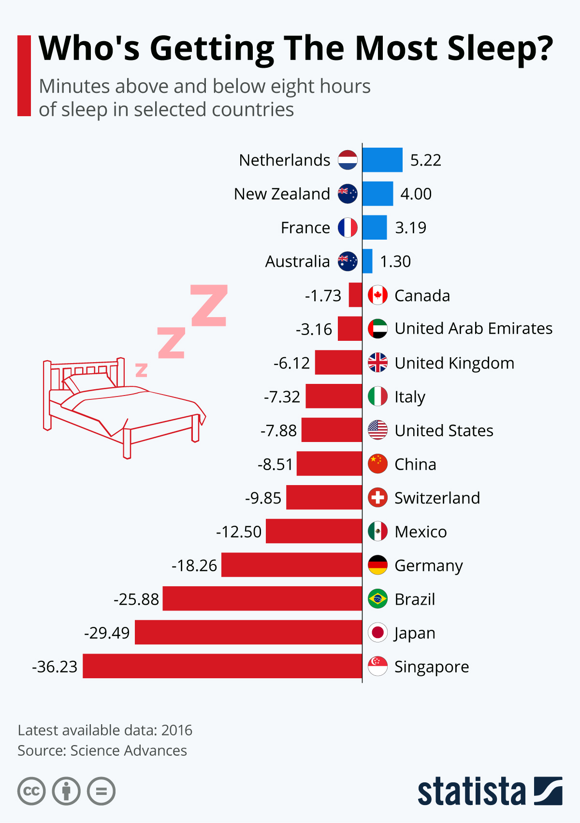
(Based on: Who's Getting The Most Sleep? [online]. 2020, May 15.
Available: https://www.statista.com/chart/4845/countries-in-which-people-are-getting-the-most-sleep/)
Questions:
- Is having a daily routine important for physical and mental wellbeing?
- Why do teenagers sometimes sacrifice sleep for other activities?
- Do you ever think sleep wastes valuable time spent doing useful things?
Paper 5

You are taking part in an English debate club discussion on consumerism. You should give a talk in which you present your opinion on the issue. Study the provided materials (their format, content, arguments) in order to plan your talk.

1) Deliver the talk in which you:
- formulate the issue raised in the materials;
- compare the information provided in the materials;
- state your opinion on the issue;
- support your opinion by at least two arguments giving reasons and examples;
- come to a conclusion.
2) Answer the teacher’s (opponent’s) questions and justify your answer.
You have up to 5 minutes to plan your talk. Speaking time: 3–5 minutes

Excessive consumerism has been a part of YouTube culture for close to a decade. Some videos feature YouTubers showing off their purchases, while “unboxing” videos feature people constantly buying and opening new things on camera. On top of all of this, vloggers create direct adverts for brands and sell their own personal merchandise. It seems logical that this incredible display of materialism is affecting at least some of the young audience that make up YouTubers’ most loyal fans.
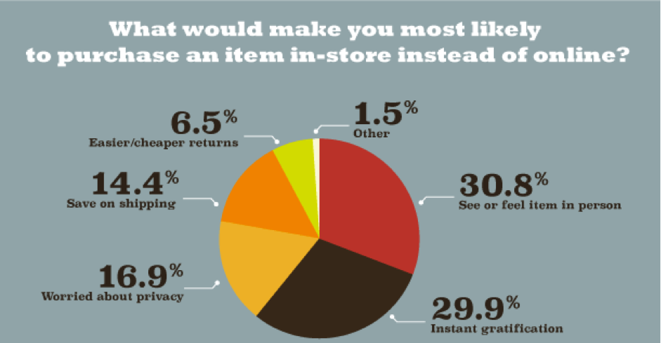
(Based on: Consumer Psychology [online]. 2021, November27.
Available: https://www.emotiv.com/glossary/consumer-psychology/ )

Questions:
- How does advertising affect our lives?
- Who suffers and who benefits from consumerism?
- Do you believe special occasions like Christmas or Easter have become too consumeristic?

Paper 6

You are taking part in an English debate club discussion on laziness. You should give a talk in which you present your opinion on the issue. Study the provided materials (their format, content, arguments) in order to plan your talk.

1) Deliver the talk in which you:
- formulate the issue raised in the materials;
- compare the information provided in the materials;
- state your opinion on the issue;
- support your opinion by at least two arguments giving reasons and examples;
- come to a conclusion.
2) Answer the teacher’s (opponent’s) questions and justify your answer.
You have up to 5 minutes to plan your talk. Speaking time: 3–5 minutes

It is a cruel fact in present-day society that some of the best activities imaginable – napping on the sofa, watching your favourite movie, reading a book with a cat on your knee that occasionally paws the pages – are considered lazy or unworthwhile. Actually, according to experts, laziness might in fact be good for your health. Spending a little time away from your desk, or muting your emails for a few hours, or finally allowing yourself to relax might actually benefit your brain and body.
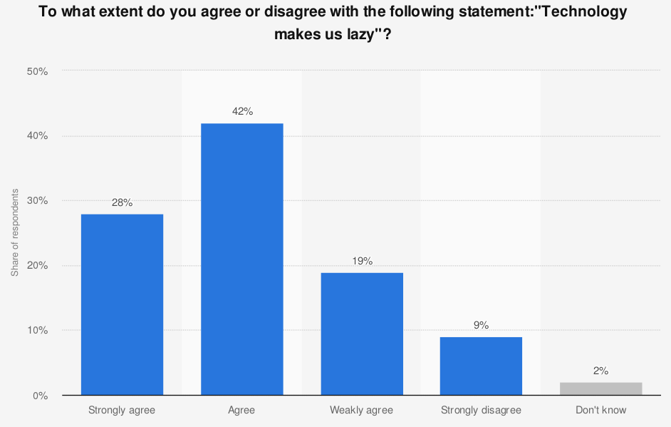
(Based on: Laziness [online]. 2020, March 7. Available: https://www.psychologytoday.com/intl)
Questions:
- What can be done to achieve a good work-life balance?
- In what ways can enjoying life away from work affect your performance at work?
- Do you estimate how much time it takes to complete a task? Do you think it’s a good idea?
References:

- Business English. (2008). Charts, Graphs and Diagrams. https://www.ilc.cuhk.edu.hk/files/ChartsGraphs_Gilhooly.pdf
- Castro, A. (2021). Writing Task 1: Phrases and Collocations for Describing Tables, Graphs and Charts. https://ieltsamericas.com/writing-task-1-phrases-and-collocations-for-describing-tables-graphs-and-charts/
- Grussendorf, M. (2007). English for Presentations. Oxford: Oxford University Press.
- IELTS Academy (n.d.). Line Graphs for The IELTS Academic. Writing https://www.ieltshelpnow.com/academic_writing_test_1.html
- Macmillan Dictionary. (n.d.). Graphs, charts and diagrams. https://www.macmillandictionary.com/thesaurus-category/british/graphs-charts-and-diagrams
- Microsoft: Educator Center. (n.d.). How to create effective charts and diagrams. https://education.microsoft.com/en-us/course/0a60eeb6/7
- Skola2030. (2021). Angļu valoda optimālajā mācību satura apguves līmenī: Valsts pārbaudes darba paraugs. https://mape.skola2030.lv/resources/9486
- Valcheva, S. (n.d.). Types of Graphs and Charts And Their Uses. https://www.intellspot.com/types-graphs-charts/
- VISC. (2021). ANGĻU VALODA: Centralizētais eksāmens par vispārējās vidējās izglītības apguvi. https://www.visc.gov.lv/lv/media/13991/download

Author: Anna Sidorova

