The Handout ‘Self-Directed Learning Guide’

User Guide
(a) in the handout you may use both theoretical information (📊description and definition of bars/charts, and 📝useful vocabulary), and 🗣 practical tasks (speaking papers);
(b) the speaking papers may be printed out and used for the exam preparation;
(c) the feedback on improving the handout is welcomed. :)

What is Bloom’s Taxonomy
Bloom’s Taxonomy is a classification of the different objectives and skills that educators set for their students (learning objectives). The taxonomy was proposed in 1956 by Benjamin Bloom, an educational psychologist at the University of Chicago. The terminology has been recently updated to include the following six levels of learning. These 6 levels can be used to structure the learning objectives, lessons, and assessments (Shabatura, 2013; Lewis, 2019):

- Remembering: Retrieving, recognizing, and recalling relevant knowledge from long‐term memory.
- Understanding: Constructing meaning from oral, written, and graphic messages through interpreting, exemplifying, classifying, summarising, inferring, comparing, and explaining.
- Applying: Carrying out or using a procedure for executing, or implementing.
- Analysing: Breaking material into constituent parts, determining how the parts relate to one another and to an overall structure or purpose through differentiating, organising, and attributing.
- Evaluating: Making judgments based on criteria and standards through checking and critiquing.
- Creating: Putting elements together to form a coherent or functional whole; reorganising elements into a new pattern or structure through generating, planning, or producing.
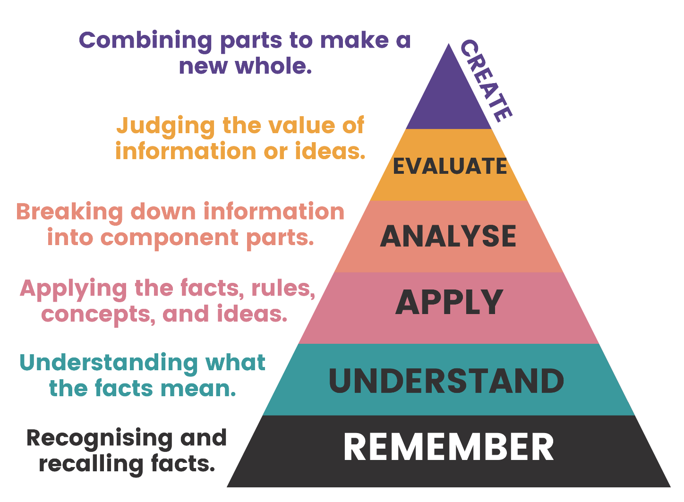

Picture: canva.com
How Bloom’s works with learning objectives

Fortunately, there are ‘verb tables’ to help identify which action verbs align with each level in Bloom’s Taxonomy (see Table 1). You may notice that some of these verbs on the table are associated with multiple Bloom’s Taxonomy levels. These “multilevel-verbs” are actions that could apply to different activities. For example, you could have an objective that states “At the end of this lesson, students will be able to explain the difference between H2O and OH-.” This would be an understanding level objective. However, if you want to be able to “…explain the shift in the chemical structure of water throughout its various phases.” This would be an analysing level verb. Adding to this confusion, you can locate Bloom’s verb charts that will list verbs at levels different. Just keep in mind that it is the skill, action or activity you will learn using that verb that determines the Bloom’s Taxonomy level (Shabatura, 2013; Lewis, 2019).

Table 1. Bloom’s Taxonomy Key Verbs
Bloom’s Level | Key Verbs (keywords) | Example Learning Objective
Create | design, formulate, build, invent, create, compose, generate, derive, modify, develop | A student will be able to design an original homework problem dealing with the principle of conservation of energy.
Evaluate | choose, support, relate, determine, defend, judge, grade, compare, contrast, argue, justify, support, convince, select, evaluate | A student will be able to determine whether using conservation of energy or conservation of momentum would be more appropriate for solving a dynamics problem.
Analyse | classify, break down, categorise, analyse, diagram, illustrate, criticise, simplify, associate | A student will be able to differentiate between potential and kinetic energy.
Apply | calculate, predict, apply, solve, illustrate, use, demonstrate, determine, model, perform, present | A student will be able to calculate the kinetic energy of a projectile.
Understand | describe, explain, paraphrase, restate, give original examples of, summarise, contrast, interpret, discuss | A student will be able to describe Newton’s three laws of motion in her/his own words.
Remember | list, recite, outline, define, name, match, quote, recall, identify, label, recognise | A student will be able to recite Newton’s three laws of motion.

There are several aspects you should remember about explaining the data according to the charts/graphs/diagrams. For instance, the correct use of tenses when describing a chart. If the chart deals with facts in the present, use the Simple Present, if the facts are the past, then use the Simple Past. If there is a connection between the past and the present, use the Present Perfect. It is important that you introduce the visual data by using one of the following phrases or collocations (Castro, 2021):

Draft of the Transcript on ‘HACKSCHOOLING MAKES ME HAPPY’ (by Logan LaPlante)

‘But what if we didn’t make it separate? What if we based education on the study and practice of being happy and healthy? Because that’s what it is: a practice. And a simple practice like that. Education is important, but why is being happy and healthy not considered education? I just don’t get it.

So I’ve been studying the science of being happy and healthy. It really comes down to practicing these 8 things: Exercise, diet and nutrition, time in nature, contribution and service to others, relationships, recreation, relaxation and stress management, and religious or spiritual involvement. Yes, I got that one. So these 8 things come from Dr. Roger Walsh. He calls them “Therapeutic Lifestyle Changes” or TLCs for short, He’s a scientist that studies how to be happy and healthy.

In researching this talk, I got a chance to ask him a few questions like: “Do you think that our schools today are making these 8 TLCs a priority?” His response was no surprise. It was essentially “No”. But he did say that many people do try to get this kind of education outside of the traditional arena through reading or practices such as meditation or yoga.

But what I thought was his best response was that much of education is oriented, for better or worse, towards making a living rather than making a life. In 2006, Sir Ken Robinson gave the most popular TED talk of all time, “Schools Kill Creativity.” His message is that creativity is as important as literacy, and we should treat it with the same status. A lot of parents watched those videos, some of those parents like mine counted it as one of the reasons they felt confident to pull their kids from traditional school, to try something different. I realize that I am part of this small but growing revolution of kids who are going about their education differently. And you know what? It freaks a lot of people out.

Even though I was only 9 when my parents pulled me out of the school system, I can still remember my mom being in tears when some of her friends told her she was crazy, and it was a stupid idea. Looking back, I’m thankful she didn’t cave to peer pressure, and I think she is too.

So out of the 200 million people that have watched Sir Ken Robinson’s talk, why aren’t there more kids like me out there? Shane McConkey is my hero. I loved him because he was the world’s best skier. But then one day I realized what I really loved about Shane. He was a hacker. Not a computer hacker, he hacked skiing. His creativity and inventions made skiing what it is today, and why I love to ski.

A lot of people think of hackers as geeky computer nerds who live in their parent’s basement, and spread computer viruses. But, I don’t see it that way. Hackers are innovators. Hackers are people who challenge and change the systems to make them work differently, to make them work better. It’s just how they think, it’s a mindset.

I’m growing up in a world that needs more people with the hacker mindset, and not just for technology. Everything is up for being hacked, even skiing, even education. So whether it’s Steve Jobs, Mark Zuckerberg or Shane McConkey, having the hacker mindset can change the world.

Healthy, happy, creativity, and the hacker mindset are all a large part of my education. I call it “Hack-Schooling“. I don’t use any one particular curriculum, and I’m not dedicated to any one particular approach. I hack my education. I take advantage of opportunities in my community, and through a network of my friends and family. I take advantage of opportunities to experience what I’m learning. And I’m not afraid to look for shortcuts or hacks to get a better, faster result. It’s like a remix or a mashup of learning. It’s flexible, opportunistic, and it never loses sight of making happy, healthy and creativity a priority. And here’s the cool part because it’s a mindset, not a system. Hack-schooling can be used by anyone, even traditional schools.’

Full video: https://www.tedxtokyo.com/translated_talk/hackschooling-makes-me-happy/
g

References:

- LaPlante, L. (2013). Hackschooling makes me happy. https://www.tedxtokyo.com/translated_talk/hackschooling-makes-me-happy/
- Lewis, B. (2019). Using Bloom's Taxonomy for Effective Learning. https://www.thoughtco.com/blooms-taxonomy-the-incredible-teaching-tool-2081869
- Shabatura, J. (2013). Using Bloom’s Taxonomy to Write Effective Learning Objectives. https://tips.uark.edu/using-blooms-taxonomy/

Author: Anna Sidorova

